**E115 – Programming and Data Analysis**

**Practice questions for Week 04**

**Select Case and Do While**

1. Rewrite the following If-Else block into a Select Case block so that the same message will be displayed in the message box.

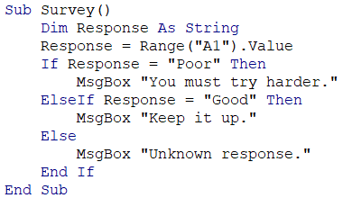

1. Rewrite the following Select Case block into an If-Else block so that the same message will be displayed in the message box.

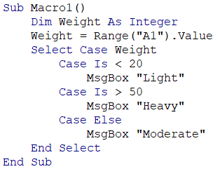

1. Rewrite the following “Do While” loop into a “For… Next” loop so that the variable **counter** that is displayed in the message box is the same for both the “For… Next” loop and the “Do While” loop.

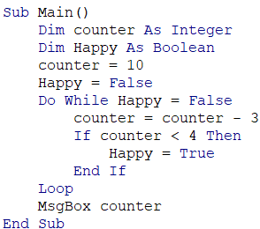

1. Rewrite the following “For… Next” loop into a “Do While” loop so that the variable **counter** that is displayed in the message box is the same for both the “For… Next” loop and the “Do While” loop.

